Chapter Arguments and Assumptions

Does literature suggest we are miscalculating the roller load from experimental analysis?

* Could show the bearing rig displacement results – very small
* Disparities in wear
* Disparities in contact load or inner race displacement of models compared to experimental results
* Read Rahnejat and Mohammadpour Papers

Why no centrifugal forces?

* Negligible – in the order of 3N due to roller mass – in comparison to the total contact loading

No hydrodynamic cage forces

* Very small and do not need to be considered for this analysis – Mohammadpour paper

Slicing technique with no edge effects

* 12 month review submission - de Mul et al. [1] compared the slicing technique with their more complex non-Hertzian model and concluded that the simplicity and accuracy of the slicing method yielded accurate and faster results. Harris and Kotzalas [2] also concluded that the slicing technique, whilst unable to reflect edge stress concentrations, provides a fairly accurate load-displacement result as stresses are only distributed over a small area. For the purpose of load equilibrium these stresses can be neglected. Misalignment or loading on roller ends is not captured using this technique, therefore for fatigue life estimates this may produce non-conservative results; for this the approach by Kabus et al. [60] should be used. In general, the slicing technique is the most widely used, owing to its simplicity, speed and sufficient accuracy.
* 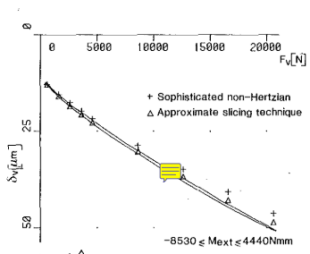
* Have got validation of my contact model with these curves

EHL Validation

* Masjedi and Khonsari

Flexible Shaft Model Validation

* If restrictions permit, modify rig to allow experimental testing and validation of current shaft model
  + Dry vs lubricated comparisons for inner race displacement (remove or add lubricant for same preload)
  + Flexible brackets?

Why no transient squeeze term in EHL code?

* For the purpose of force equilibrium and implicit inclusion of EHL film, analytical equations are used for computational efficiency currently. Squeeze term is not accounted for in these
* For full EHL this functionality wasn’t added as it wasn

Why no starvation or cavitation in EHL code?

Starvation does increase with speed, however decrease with load

Load is function of film… so would have to go off experimental results to see what conditions starvation occurred at – OR full numerical.

Why no thermal EHL?

[1] J. M. de Mull, J. M. Vree, and D. A. Maas, “Equilibrium and associated load distribution in ball and roller bearings loaded in five degrees of freedom while neglecting friction - part I: application to roller bearings and experimental verification.,” vol. 111, no. January, 1988.

[2] T. A. Harris and M. N. Kotzales, *Advanced Concepts of Bearing Technology*, Fifth. Boca Raton, FL: Taylor and Francis Group, 2007.